PROGRAMMING IN C

**MINI PROJECT**

NAME: **VANISRI KIRUBAKARAN**

DEPARTMENT: **INFORMATION TECHNOLOGY**

REGISTER NUMBER: **312417205054**

ROLL NUMBER: **17IT1109**

YEAR: **01**

SEMESTER: **02**

SUBJECT: **C PROGRAMMING**

**AIM:**

To write a C program to compute tax based on gross income.

The obtained income has to be divided into slab codes where the corresponding income is to be placed. The division of income is as follows:

For income<10000, slab code=0

For 20000>income>=10000, slab code=1

For 30000>income>=20000, slab code=2

For 40000>income>=30000, slab code=3 or 4

For income>=50000, slab code=5

The rates of tax on gross income are as shown below,

|  |  |
| --- | --- |
| **Income** | **Tax** |
| <Rs.10,000 | Nil |
| Rs.10,000to Rs.19,999 | 10% |
| Rs.20,000 to Rs.29,999 | 15% |
| Rs.30,000to Rs.49,999 | 20% |
| >Rs.50,000 | 25% |

A program is required to compute the tax based on the above data.

**ALGORITHM:-**

STEP 1: Start the program with necessary header files.

STEP 2: Declare income and slab_code variables.

STEP 3: Read income from the user.

STEP 4: Assign slab code to the income.

STEP 5: Calculate tax amount.

STEP 6: Print tax amount.

STEP 7: Close the program.

**FLOW CHART:-**

start

read input

multiple if conditions

to assign slab_code

and tax

calculate tax

print tax

stop

**SOURCE CODE:-**

#include<stdio.h>

#include<conio.h>

int main()

{

float income = 0, hra=0, med=0, tra=0, ta=0,income2=0;

int slab_code = 0;

clrscr();

printf(“INCOME TAX CALCULATION”);

printf(“\n* Income tax is valid only for minimum annual income 95,000 Rs. and above *”);

printf(“\nEnter gross salary per annum:”);

scanf(“%f”,&income);

printf(“\nEnter HRA per month\n(Rs.5,000 as per budget 2017):”);

scanf(“%f”,&hra);

printf(“\nEnter Medical Allowance per month\n(Rs.1,500 as per budget 2017):”);

scanf(“%f”,&med);

printf(“\nEnter Travel Allowance per month\n(Rs.800 as per budget 2017):”);

scanf(“%f”,&tra);

hra=hra*12;

med=med*12;

tra=tra*12;

ta=hra+med+tra;

income2=income-ta;

printf(“\n\tgross salary p.a:\t\t%f”,income);

printf(“\n\tHouse Rent Allowance p.a:\t%f”,hra);

printf(“\n\tMedical Allowance p.a:\t\t%f”,med);

printf(“\n\tTravel Allowance p.a:\t\t%f”,tra);

printf(“\n\tTotal Exemption:\t\t%f”,ta);

printf(“\n\tTaxable Salary:\t\t\t%f”,income2);

if(income2<10000)

slab_code=0;

else if(income2>=10000 && income2<20000)

slab_code=1;

else if(income2>=20000 && income2<30000)

slab_code=2;

else if(income2>=30000 && income2<40000)

slab_code=3;

else if(income2>=40000 && income2<50000)

slab_code=4;

else

slab_code=5;

printf(“\n\tSlab Code:\t\t\t%d”,slab_code);

if(slab_code==0)

{

printf(“\n\tTax:\t\t\t\t NIL”);

printf(“\n\tTax on income:\t\t\t 0 Rs”);

}

else if(slab_code==1)

{

printf(“\n\tTax:\t\t\t\t 10%”);

printf(“\n\tTax on income:\t\t\t %f Rs”,(0.1*income2));

}

else if(slab_code==2)

{

printf(“\n\tTax:\t\t\t\t 15%”);

printf(“\n\tTax on income:\t\t\t %f Rs”,(0.15*income2));

}

else if(slab_code==3||slab_code==4)

{

printf(“\n\tTax:\t\t\t\t 20%”);

printf(“\n\tTax on income:\t\t\t %f Rs”,(0.2*income2));

}

else

{

printf(“\n\tTax:\t\t\t\t 25%”);

printf(“\n\tTax on income:\t\t\t%f Rs”,(0.25*income2));

}

getch();

return 0;

}

**OUTPUT:-**

**Test Case 1:**

**When annual income is 96,000 Rs and slab code is 0-**

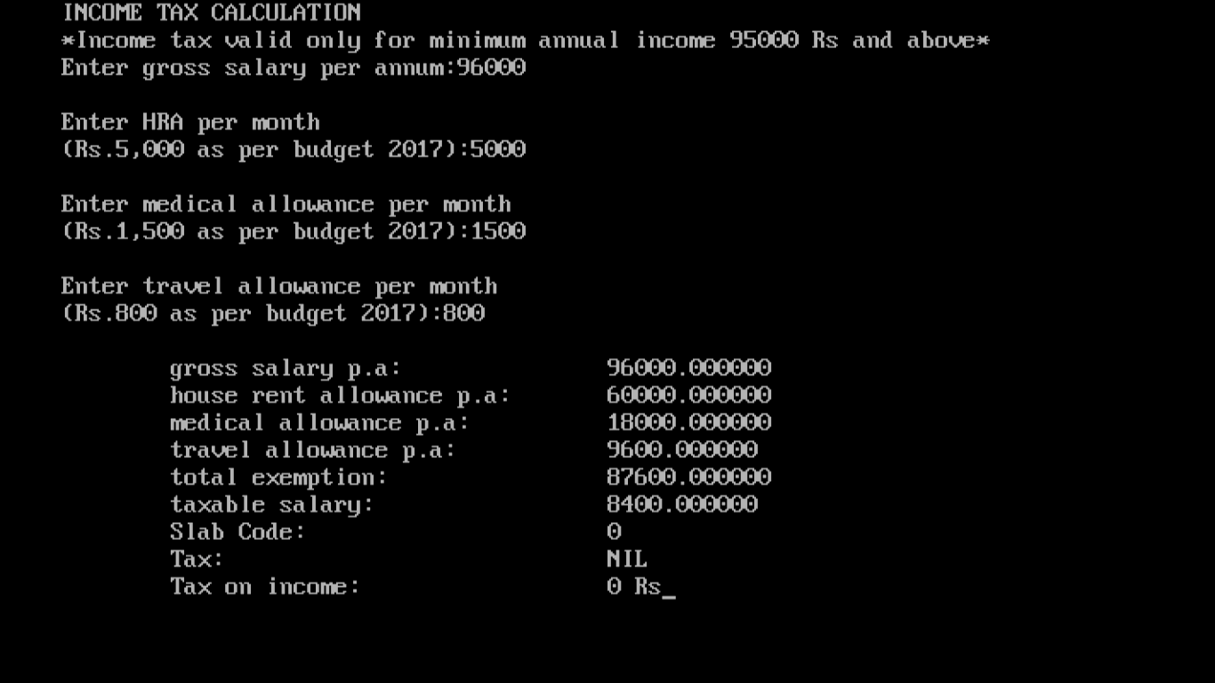

**Test Case 2:**

**When annual income is 1,20,000 Rs and slab code is 3-**

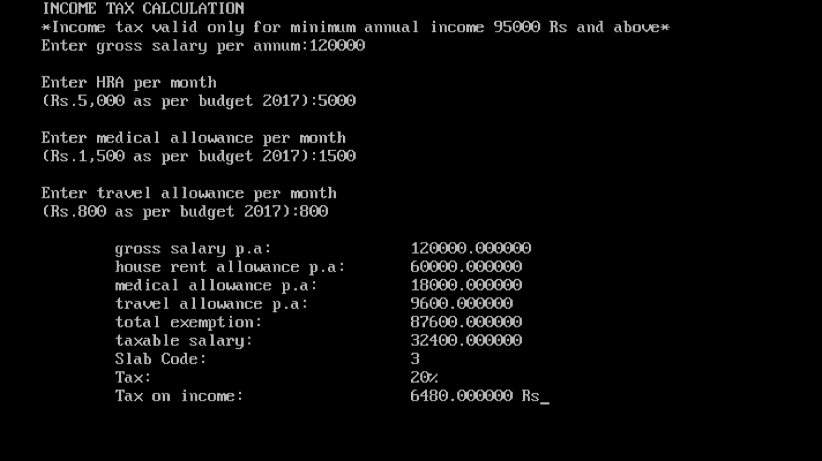

Test Case 3:

When annual income is 3,00,000 Rs and slab code is 5.

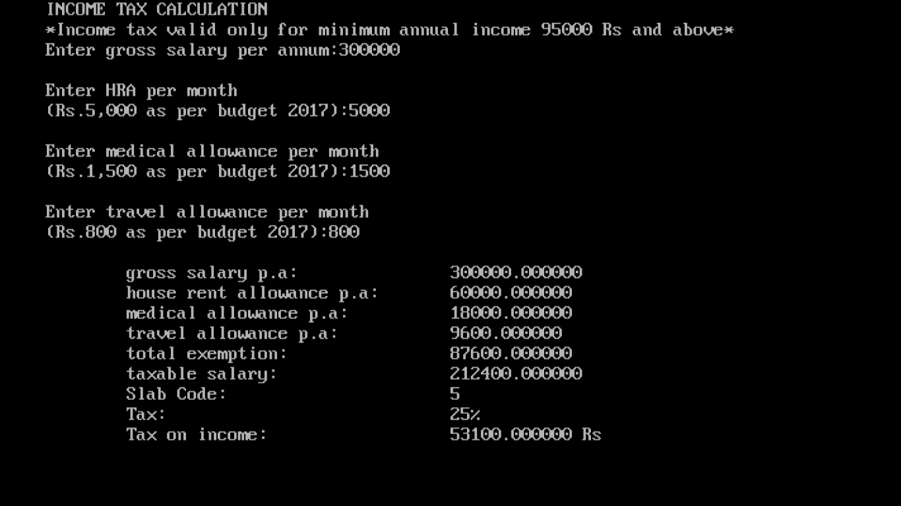

**RESULT:-**

The tax was computed for the entered income.

Thus, the C program for tax calculation was executed successfully.